**A**

**Project Report**

**On**

**“Expense Manager”**

**SUBMITED BY**

Mr. Shubham Sanjay Sahane

**GUIDE By**

**Prof. Kalyani Alisetty**

**Dept. M.C.A.**



**SUBMITTED TO**

**SAVITRIBAI PHULE PUNE UNIVERSITY**

In partial fulfilment of the award of the degree Of

**MASTERS IN COMPUTER APPLICATION**



**SINHGAD INSTITUTE OF BUSINESS ADMINISTRATION AND RESEARCH**

**KONDHWA, PUNE-411048**

**During Academic Year**

**2021-2022**

**CERTIFICATE OF APPROVAL**

This is to certify that the project report entitled **Expense Manager** submitted to the Department of Computer Application, Sinhgad Institute of Business Administration and Research in partial fulfillment of the requirement for the award of the Degree of MASTER OF COMPUTER APPLICATIONS (MCA Affiliated to Savitribai Phule Pune University) is an original work carried out by,

**Name: Shubham Sanjay Sahane.**

**Seat No:**

The matter embodied in this project is a genuine work done by the student and has been certified by the following internal and external examiners deputed by Savitribai Phule Pune University.

Internal Examiner External Examiner

**CERTIFICATE OF ORIGINALITY**

This is to certify that the project report entitled **Expense Manager** Submitted to the Department of Computer Applications, Sinhgad Institute of Business Administration and Research in partial fulfillment of the requirement for the award of the degree of MASTER OF COMPUTER APPLICATIONS (MCA Affiliated to Savitribai Phule Pune University), is an original work carried out by,

**Mr. Sahane Shubham Sanjay** Exam No: 17661

under my guidance.

The matter embodied in this project is a genuine work done by the student and has not been submitted whether to this Organization or to any other University/ Organization for the fulfillment of the requirement of any course of study.

Signature of the Student :

Name of the student : Sahane Shubham Sanjay.

Signature of the Guide :

Name and Designation of the Guide : Prof. Kalyani Alisetty

Signature of Director-MCA

**Dr. Netra Patil**  :

Date : **29 / 12 / 2022**

**INDEX**

|  |  |  |
| --- | --- | --- |
| **SR.NO** | **TITLE** | **PAGE** |
| **1** | **INTRODUCTION** |  |
| 1.1  1.2  1.3  1.4 | Introduction  Existing System  Need for System  Limitations of existing system |  |
| **2** | **PROPOSED SYSTEM** |  |
| 2.1  2.2  2.3  2.4  2.5  2.6  2.7  2.8  2.9  2.10  2.11 | Proposed System  Problem statement/s  Product overview  Summary of Capabilities  Objective of Proposed System  Functional Requirement’s  Non-Functional Requirement  Users Summary  Scope of System  Module Specification  Operating Environment |  |
| **3** | **REQUIREMENT AND ANALYSIS** |  |
| 3.1  3.2  3.3 | Fact finding Methods  Feasibility Study  Hardware And Software Requirement |  |
| **4** | **SYSTEM ANALYSIS & DESIGN** |  |
| 4.1  4.2  4.3  4.4  4.5  4.6  4.7  4.8  4.9  4.10 | Use Case Diagram  Activity Diagram  ER Diagram  Class Diagram  Object Diagram  Sequence Diagram  Data Flow Diagram  Deployment Diagram  Table Specification (Database)  User Interface Design (Screens etc.) |  |
| **5** | **USER MANUAL** |  |
| 5.1  5.2  5.3  5.4 | Drawback and Limitations  Proposed Enhancements  Conclusion  Bibliography |  |

**CHAPTER 1**

1. **Introduction**

Daily Human Expense Application is designed to keep a track of Income-Expense of a Human on a day-to-day basis. If you exceed day’s expense, application will cut it from your income and will provide new daily expense allowed amount. If that day’s expense is less, application will add it in savings. Daily expense tracking Application will generate report at the end of month to show Income-Expense Curve.

It will be able to generate your expenses and saving report as time duration you selected. There will be a reminder that will help to save money for your pre-defined expenses. With the help of Daily Human Expense application, the user can manage their expenses on a daily, weekly, monthly and yearly basis. Users can insert and delete transactions as well as can generate and save their reports.

**1.2 EXISTING SYSTEM:**

* + - The current manual system has a lot of paper work. To maintain the records of Daily Expense and Income manually, is a Time-consuming task.
    - With the increase in database, it will become a massive task to maintain the database.
    - The retrieval of records of previously transaction will be a tedious task.
    - Lack of security for the records.
    - In existing, we need to maintain the Excel sheets, CSV etc. files for the user daily and monthly expenses.
    - In existing, there is no as such complete solution to keep a track of its daily expenditure easily.
    - To do so a person as to keep a log in a diary or in a computer, also all the calculations need to be done by the user which may sometimes results in errors leading to losses.

**1.3 NEED FOR SYSTEM:**

* + - Our present modern information system makes use of Mobile Devices for the execution, each of them connected through an optimized network. Expense Manager is the most important aspect of our society, and many Expense Manager apps providers face challenges to offer practical and active services to Peoples.
    - Apart from that automating your Expense Manager processes and implementing them cannot be done too easily, you need an efficient Expense management system to take care of everything that is happening around.
    - Processing Speed & Results
    - Cost Effective
    - Reduction in Errors
    - Data Security & Retrieving Ability

**1.4 LIMITATIONS:**

* + - Lack of security of data.
    - person as to keep a log in a diary or in a computer.
    - all the calculations need to be done by the user which may sometimes results in errors leading to losses.
    - Time Consuming.
    - Consumes large Volume of Paper work.
    - Manual Work.

To Avoid all these limitations and make the system working more accurately it needs to be Computerized.

**CHAPTER 2**

**2.1 PROPOSED SYSTEM:**

This application can take a good market as it is usable by anyone who are willing to

manage their expenses and aiming to save for the future investments and many more. There is not any range criteria or any kind of profession or gender are focused, it will used hugely.

**Limitations** - · User have to entry every record manually.

* · The category divided may be blunder or messy.
* · Person who is handling system must have some technical knowledge.

**2.2 PROBLEM STATEMENT:**

* + - The current manual system has a lot of work. To maintain the records of transaction manually, is a Time-consuming task.
    - With the increase in records, it will become a massive task to maintain the records .
    - The retrieval of records of previously transaction will be a tedious task.
    - Lack of security for the records, anyone disarrange the records of your system.
    - Search for transaction is very hard to find.

**2.3 PRODUCT OVERVIEW:**

* + - The Expense Manager is designed for Peoples to replace their existing manual, paper-based system, Excel Sheet record storing. The new system is to control the following information like Income , Expense, Graphical representation, Specification , and Users Can Submit Their Income Expense Transaction. These services are to be provided in an efficient, cost-effective manner, with the goal of reducing the time and resources currently required for such tasks.
    - A significant part of the any Expense Manager involves the Transaction Details, Visual Representation of Information. All of this information must be managed in an efficient and cost wise fashion so that an Users resources may be effectively utilized. Expense Manager will automate the management of the Transaction making it more efficient and error free. It aims at standardizing data, consolidating data ensuring data integrity and reducing inconsistencies.

**2.4 SUMMARY OF CAPABILITY:**

* + - User can Register into system.
    - Users can View all previous Transactions for Income or Expense.
    - Users Can add Income in System Accordingly income transaction.
    - User can add their custom category for transactions.
    - Users can add Expense Transactions.
    - Shows Users details in Profile Sections.
    - Can view total credit , debit ,and available amounts.
    - Register User have to verify their Email Address before login.
    - Users can reset their password.
    - Access their data by login in different divices.

**2.5 OBJECTIVE OF PROPOSED SYSTEM:**

Main objectives of a Expense Manager System are:

* + - To keep track of daily expenses and budgeting;
    - To save money for pre-defined expenses which will help planning on your future investments.
    - View all monthly’s transaction report’s.
    - Make a paper-based system to digital system.
    - Make it easy for the Users to Check their transactions according to their needs.
    - Provide users a simple way to find details.
    - Design a system for better Management .
    - Reduce Manual Document Management Costs.
    - Provide top management a single point of control.

Expense Manager system can be developed by using waterfall model which is a popular version of development life cycle model for software engineering. It describes a development method that is linear and sequential. It has distinct goals for each phase of development. In this model once, a phase of development is completed, there is no turning back, the development proceeds to the next phase. The advantage of this model is that it allows for departmentalization and managerial control.

**2.6 FUNCTIONAL REQUIREMENTS:**

There are a lot of software requirements specifications included in the functional requirements of the Expense Manager System, which contains various process, namely Registration, Add Category, Add Expense, Add Income, Firebase Realtime Database.

Registration Process:

* + - The Expense Manager enables the Users in the front desk to provide a control on registration of users and record of the data. The Users can utilize the registration ID throughout their use of system.
    - Each Register users have to verify their email Id via given link in email.
    - For forgot password users have to check link in their email.

Add Category:

* Users can add their custom category for online transaction and cash transaction from add category section.

Add Transaction:

* + - Income: The Expense Manager System can add Income transaction .
    - Expense: The Expense Manager System can add Expense transaction .

Report of Transaction:

* + - The system can show visual representation of data.

Database of Expense Manager:

* + - The System Uses firebase realtime database which require internet connection.

**2.7 Non-Functional Requirements**

There are a lot of software requirements specifications included in the non-functional requirements of the Expense Manager System, which contains various process, namely Security, Performance, Maintainability, and Reliability.

Security:

* + - Logon ID: Any users who make use of the system need to hold a Logon ID and password.
    - Modifications: Any modifications like insert, delete, update, etc. for the database can be synchronized quickly and executed only by the administrator.
    - Administrator rights: The administrator can view as well as alter any information in the Expense Manager System.

Performance:

* + - Response Time: The system provides acknowledgment in just one second once the properties information is checked.
    - Capacity: The system needs to support at least 1000 people at once.
    - User-Interface: The user interface acknowledges within five seconds.
    - Conformity: The system needs to ensure that the guidelines of the Microsoft accessibilities are followed.

Maintainability:

* + - Errors: The system will track every mistake as well as keep a log of it.

Reliability:

* + - Availability: The system is available all the time.

Hope you got a clear idea on the functional and non-functional requirements and the features required by the hospital. Any other queries on the topic are welcome.

* 1. **USERS SUMMARY:**
     + People that use system for Expense Management.
     + Admin that manages users, database and views reports of applications.

**2.9 SCOPE OF THE SYSTEM:**

* + - Login into any android device to get their transaction details.
    - Enforces Proper report Generation at all times.
    - Search transaction at any time at any ware to fulfil need.
    - A user-friendly graphical interface.
    - Provide Users Details in Profile section.
    - Admin manage Users and Database and analytics data.

**2.10 MODULES SPECIFICATIONS**

1. Login :
   * + Manage processes of Following :
2. Registration
3. Forgot Password
4. Email Verifications
   * + Watch data submitted by user.
     + Check if user already Exists.
5. Profile :

* View own profile.
* Sign Out from devices.

1. Add Transactions :

* Add Income Transactions.
* Add Expense Transactions.

1. View Transaction :

* View All previous transactions.

1. Report :

* View Graphical representation of transaction.

**CHAPTER 3**

**3.1 FACT FINDING METHODS:**

A database developer commonly uses several fact-finding techniques during a single database project.

There are five widely used fact-finding techniques:

* + - Examining documentation
    - Interviewing
    - Observing the enterprise in action
    - Research
    - Questionnaires

Let us discuss in brief each of them:

1. Examining documentation: can be helpful when you try to gain some insight as to how the requirement for a database arose. You may also find that documentation can help to acquire information on the part of the enterprise associated with the problem. If the problem relates to the current system, there should have to be documents associated with that system. By examining documents, forms, reports, and files associated with the current system, you can quickly gain some thoughtful concepts out of the system.
2. Interviewing: is the most frequently used, and usually the most useful, fact-finding procedure used. We can interview to collect information from person face-to-face. There can be several objectives for using interviewing, such as finding out facts, verifying those facts, clarifying these released facts, generating enthusiasm, getting the end-user involved, identifying requirements, and gathering ideas and opinions. However, using the interviewing practice must require proper communication skills for dealing effectively with people who have different values, priorities, opinions, motivations, and personalities.
3. Observing the enterprise in action: Observation is one of the most successful fact-finding techniques carried out for understanding a system. Using this technique, it is achievable to either participate in or observe a person perform activities to learn about the system.
4. Research: A useful fact-finding technique is to research the application or the problem that you are dealing with and want to put within a database. Computer trade journals, reference books, and the Internet are good sources of information that can make available the vast quantity of information on how others have solved similar problems/issues plus whether or not any software packages exist to resolve or even partially solve your current problem.
5. Questionnaires: Another fabulous fact-finding method is to conduct surveys through questionnaires. Questionnaires are special-purpose documents that allow facts to be gathered from a large number of people while upholding some control over their responses. When dealing with a large number of listeners or audience, no other fact-finding technique can tabulate the same facts so efficiently. There are two types of questions that can be asked in a questionnaire, namely free-format and fixed-format. Free-format questions offer the respondent greater freedom inputting answers. Fixed-format questions require specific responses from individuals, and for the given question, the respondent must choose from the available answers.

**3.2 HARDWARE AND SOFTWARE REQUIREMENT:**

|  |  |  |
| --- | --- | --- |
| **Item** | **Android (Minimum)** | **Database server (Minimum)** |
| Processor | 1.6 GHz CPU | 2 x 1.6 GHz CPU |
| RAM | 1-1.75 GB | 10 GB |
| Memory | Maximum 100MB For application. | |
| Operating System | Android API level 32. | |
| Software Requirements for Users | latest Expense Manager App or preceding 2 versions of that Expense Manager App. | |

**3.2 FEASBILITY STUDY:**

Technical Feasibility:

* + - The technical feasibility carried out for this system determined whether the planned system could be developed and design in organization using the existing technology.
    - The existing system can have expertise to use it. The organization is already equipped with require hardware and software.
    - The hardware currently available has enough memory to support software. Hence this system technically feasible.

Economical Feasibility:

* + - While considering the economical feasibility it is checked inn points like performance, information, and output from this system.
    - Economic of system at financial experts of project. It determines whether the investment that goes into the implementation of system is recoverable.
    - As the hardware and software are already available and no investment are to be made in that direction. Thus system is economical feasible.

Operational Feasibility:

* + - Operational feasibility ends at checking if the system will work in more efficient and accurate manner through all routine operations.
    - This system is made to be comprehensive in nature using a full menu driven system & appropriate user informative messages.
    - No training is required, User can easily operate the system.
    - Our system is user friendly, View of system is very simple that for not trouble for handling user.

**CHAPTER 4**

**4.1 USE CASE DIAGRAM:**

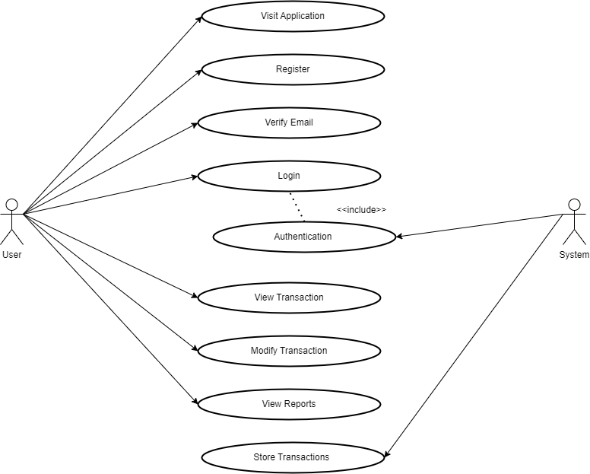

**4.2 ACTIVITY DIAGRAM:**

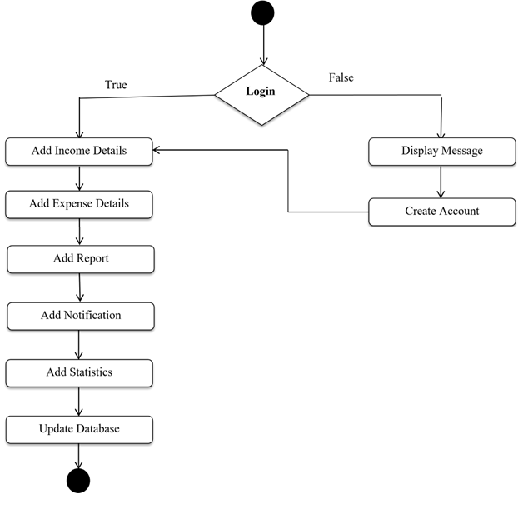

**4.3 ER DIAGRAM:**

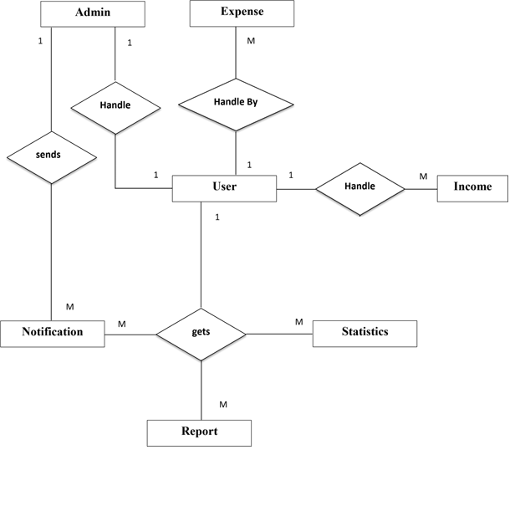

**4.4 CLASS DIAGRAM:**

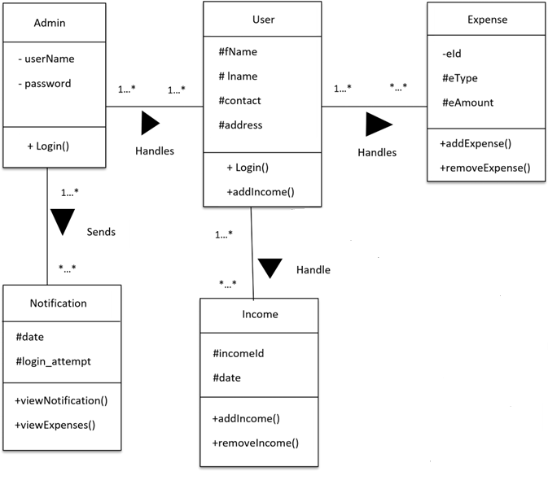

**4.5 OBJECT DIAGRAM:**

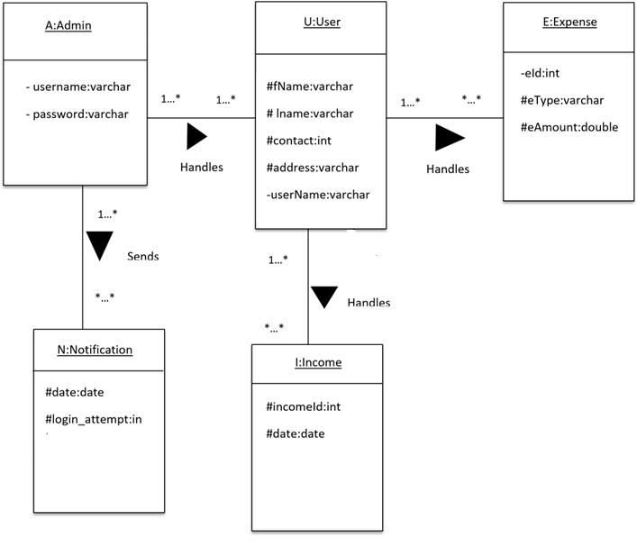

**4.6 SEQUENCE DIAGRAMS:**

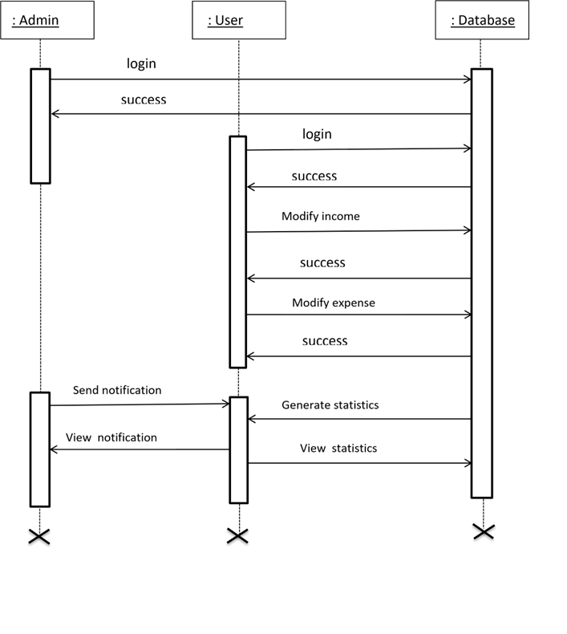

**4.7 Data Flow Diagram:**

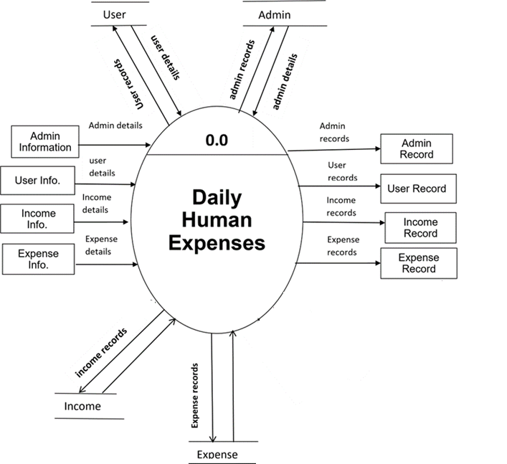

**4.8 DEPLOYMENT DIAGRAM:**

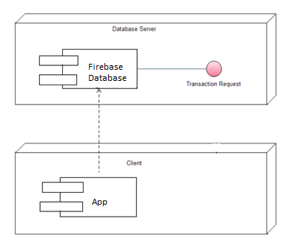

**4.9 Table Specification** **:**

Expense Table:

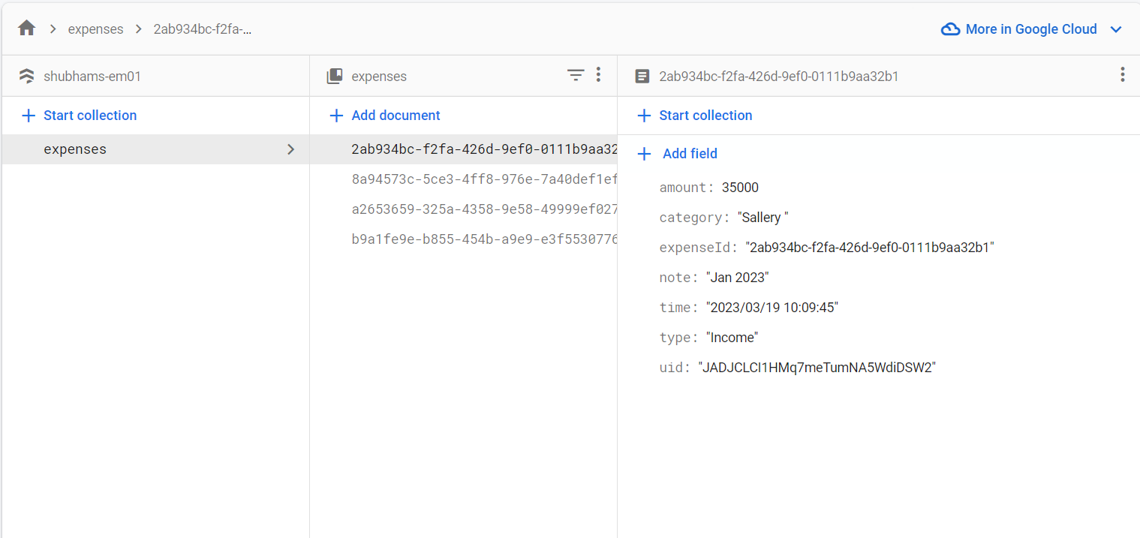

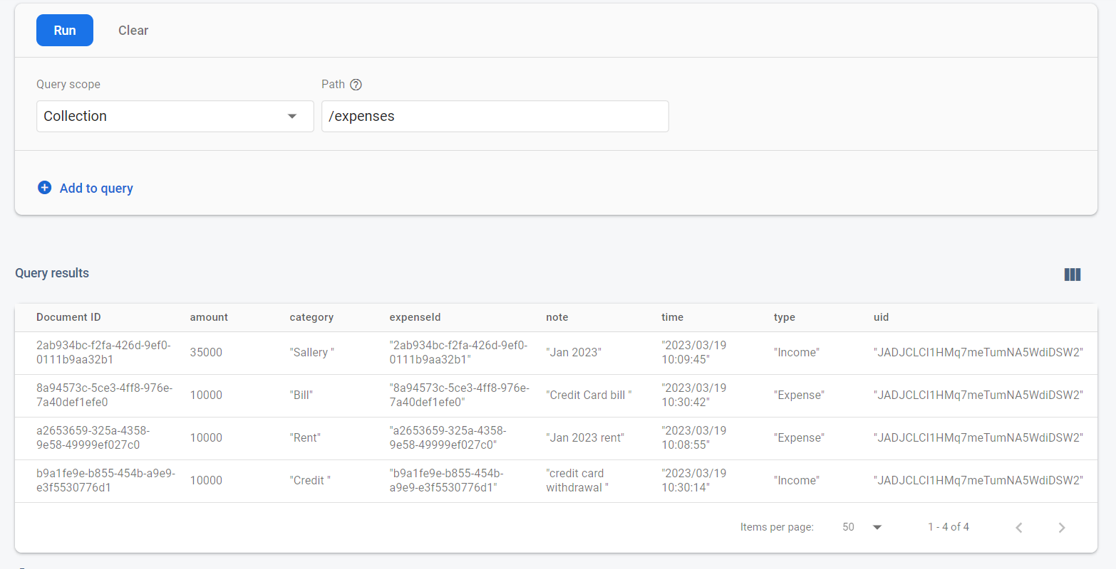

**Authentication:**

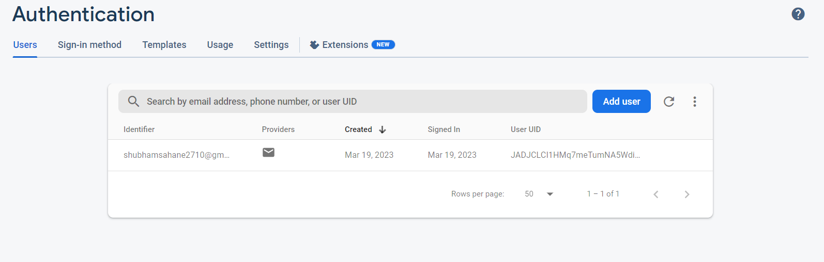

**Users :**

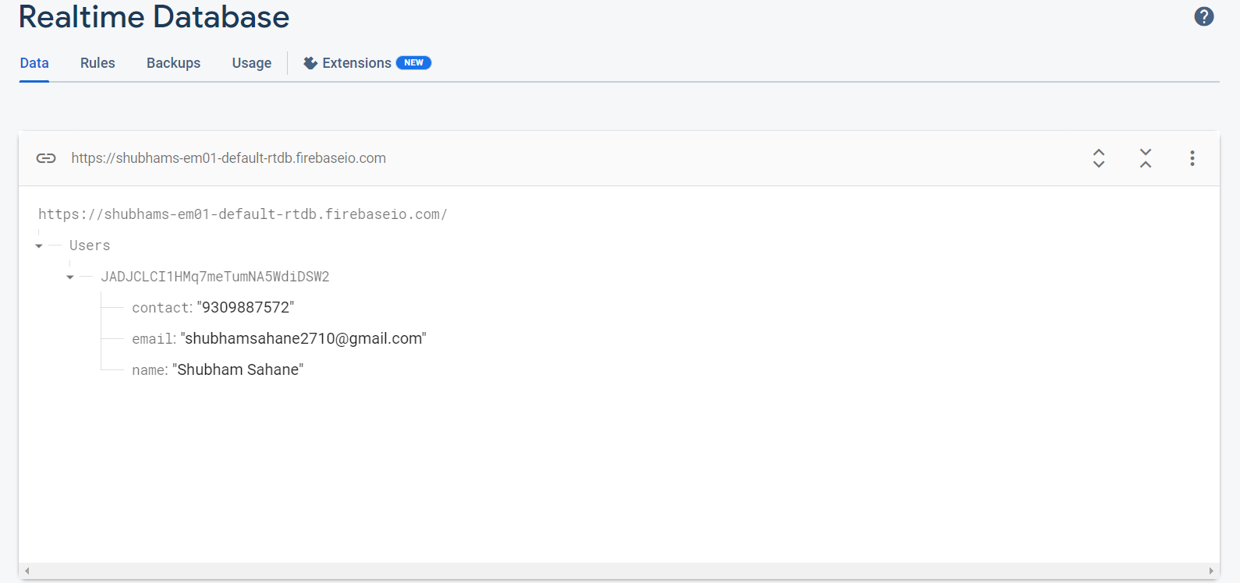

**4.10 User Interface Design:**

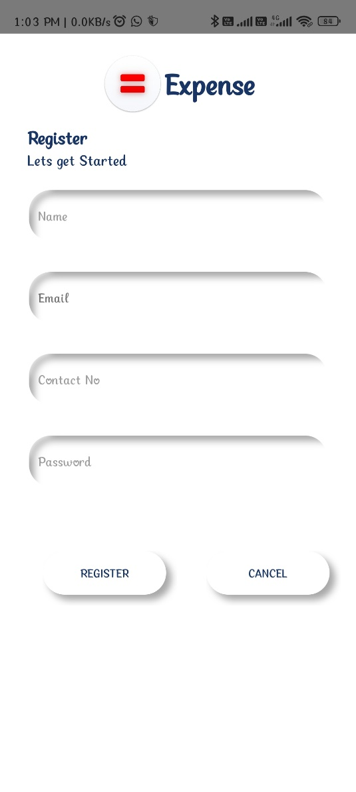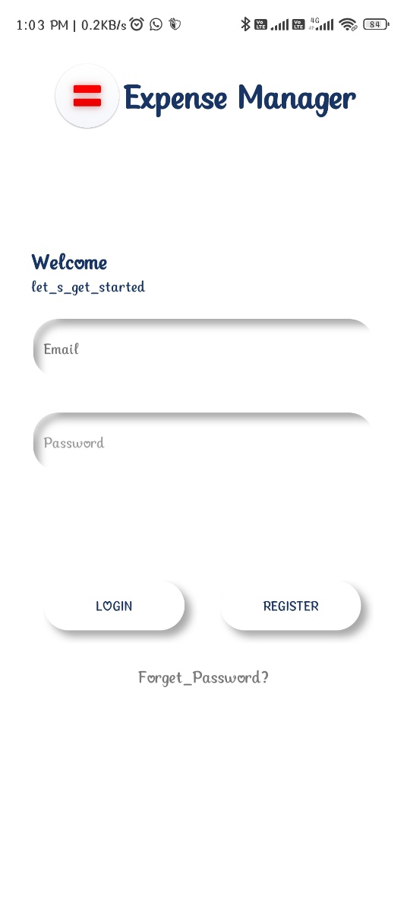

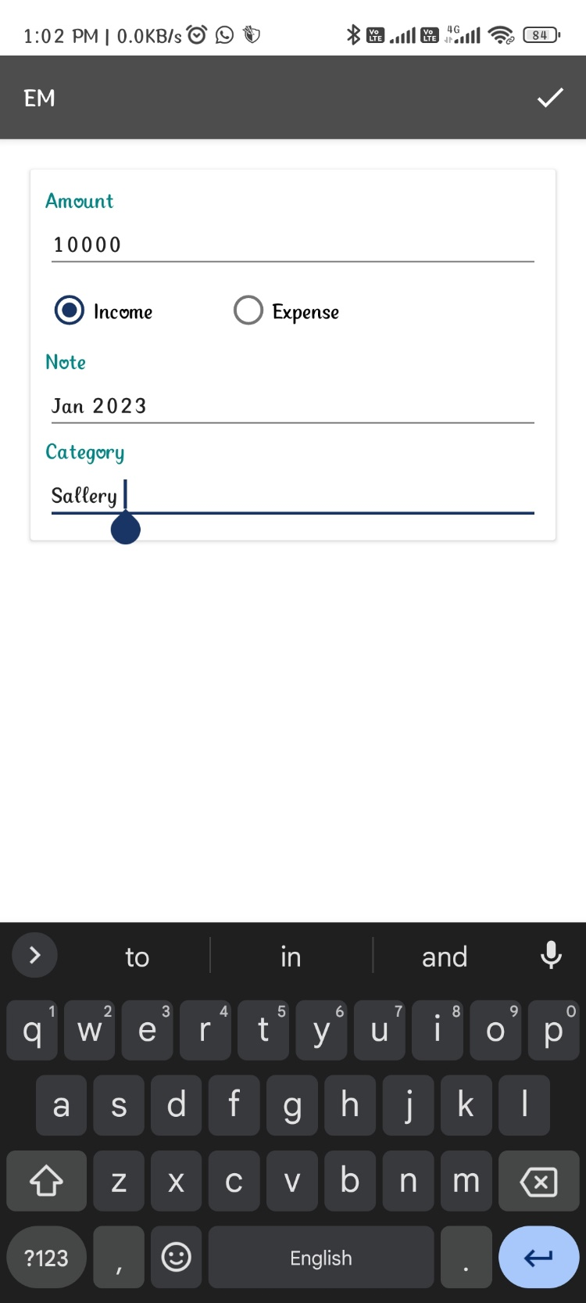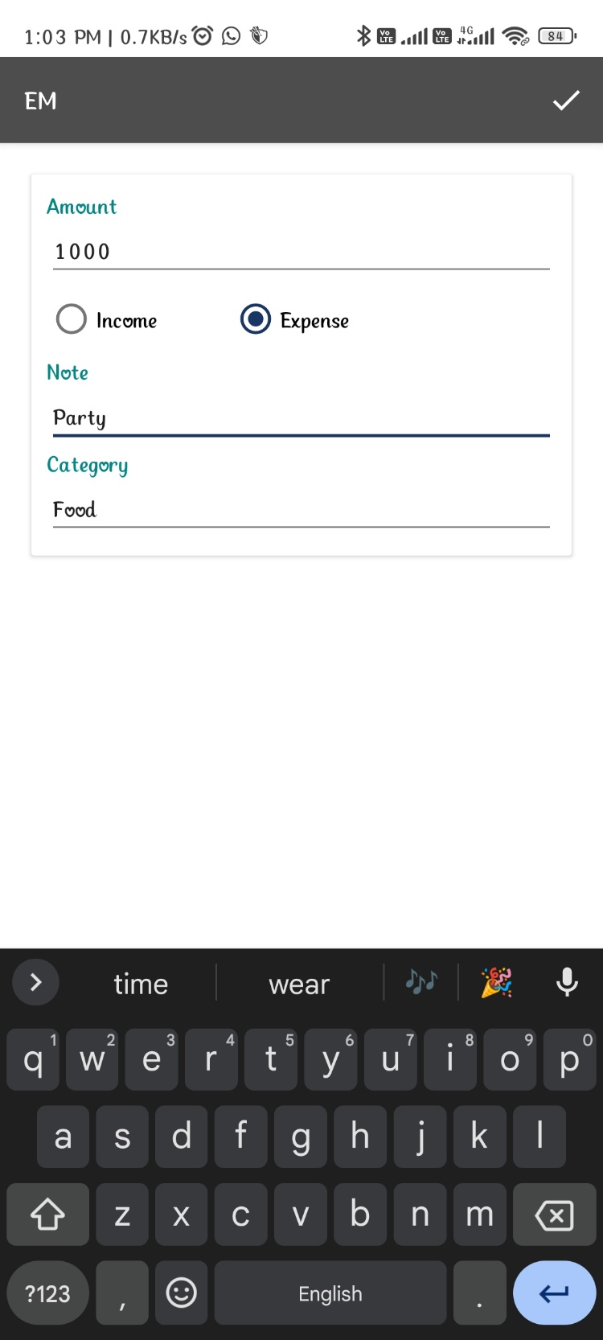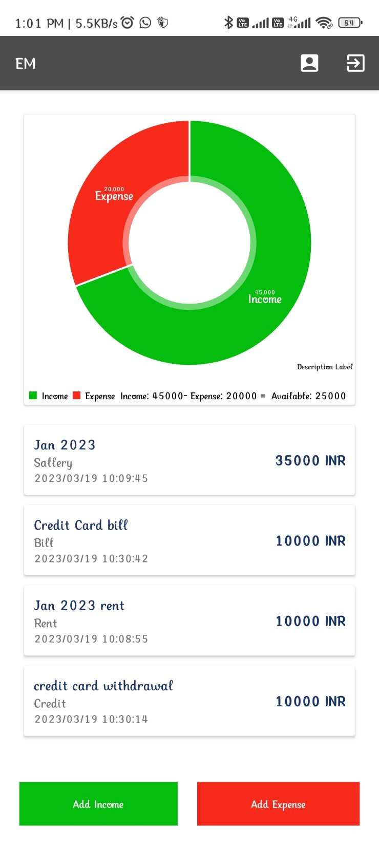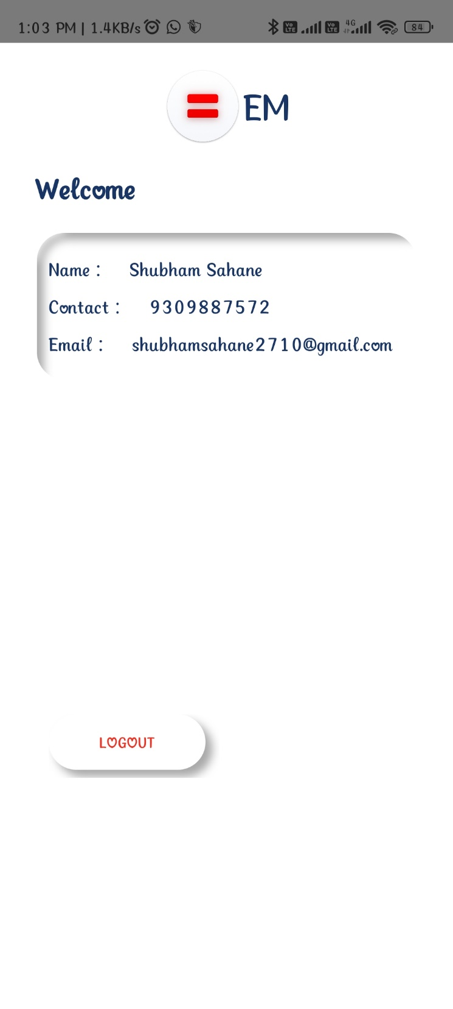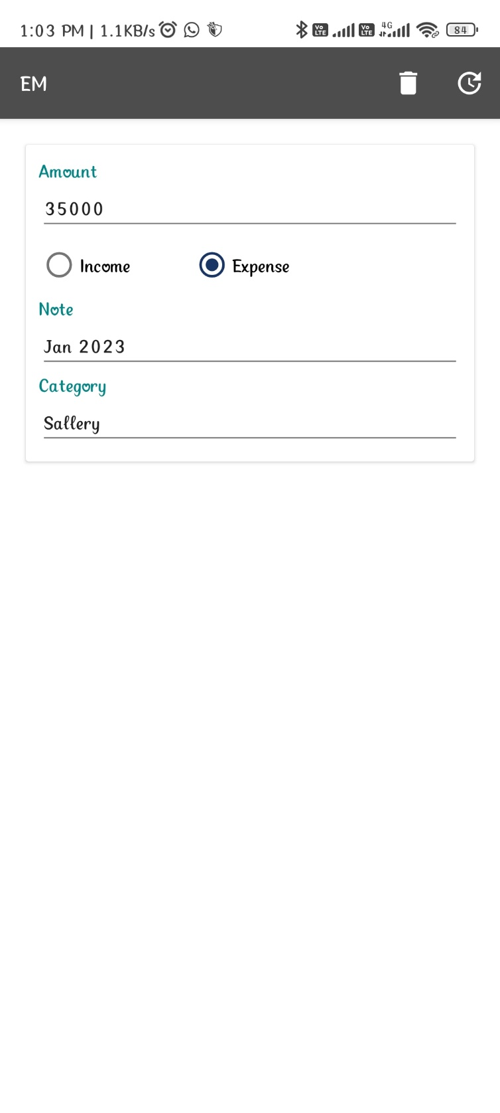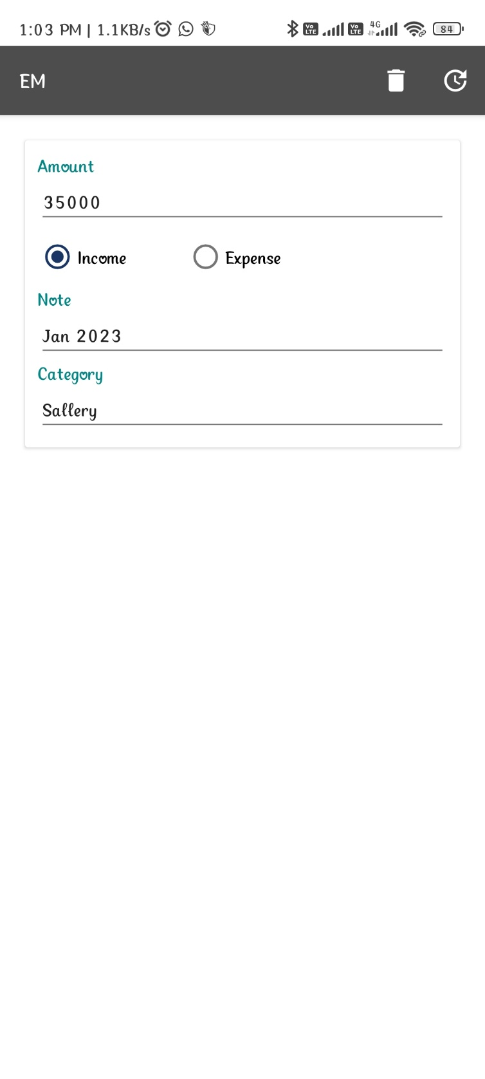

**CHAPTER 5**

**5.1 DRAWBACK AND LIMITATIONS:**

1. Update Transaction Module under Constraction.
2. Require Internet.

**5.2 PROPOSED ENHANCEMENTS:**

* + - Adding more Report Option.
    - Making this system more robust

**5.3 CONCLUSION:**

Implementation of Expense Manager system project helps to store all kinds of record’s provide coordination and user communication , implement policies , improve day-to-day operations, arrange the supply chain, manage financial and human resources.

**5.4 BIBLIOGRAPHY:**

**Website :**

* + - https://stackoverflow.com/
    - https://www.javascript.com/learn/
    - https://www.quora.com/
    - https://www.javatpoint.com/
    - https://www.w3schools.com/
    - https://www.youtube.com/

**Book’s :**

* + - Beginning Database Design - Gavin Powell
    - Agile Java Development With Spring, Hibernate, And Eclipse - Anil Hemrajani